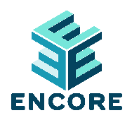
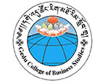

Entrepreneurship Knowledge Center (EKCs) Student Application Form
Information About Applicant

NAME:

(FIRST)
MAJOR: UNDERGRADUATE GRADUATE
(LAST)
YEAR IN PROGRAM:

E-MAIL: TELEPHONE:

Applicant’s Academic History

Number of credits completed (as of today):

Please list all academic honors, awards, extra-curricular activities, community service work, and scholarships below.

Applicant’ s Language Skills

LANGUAGE | TOTAL YEARS OF  STUDY | READING |  |  |  |  |  |  |  |  | WRITING |  |  |  |  |  |  |  |  | LISTENING |  |  |  |  |  |  |  |  | SPEAKING
 |  | Fluent |  |  | Good |  |  | Fair |  |  | Fluent |  |  | Good |  |  | Fair |  |  | Fluent |  |  | Good |  |  | Fair |  |  | Fluent |  |  | Good |  |  | Fair
1.
2.
3.
4.

Essay Questions

On an additional sheet of paper, please answer all of the following questions concisely in English:
- Write a brief autobiographical essay. Include your personal history, work experiences, community service, and travel experiences. What experiences that have most contributed to your personal development?
- How will your participation in the ENCORE Entrepreneurship Knowledge Hub help you to achieve your academic, career, and/or personal goals?

How will you contribute towards the ENCORE project goals of promoting Entrepreneurship in (Bhutan/Nepal/Lao PDR*please indicate your country)?
Submission
Please submit this application no later than November 30th, 2022.

Send completed applications to:
ADD CONTACT DETAILS

