Annexure 5A/3
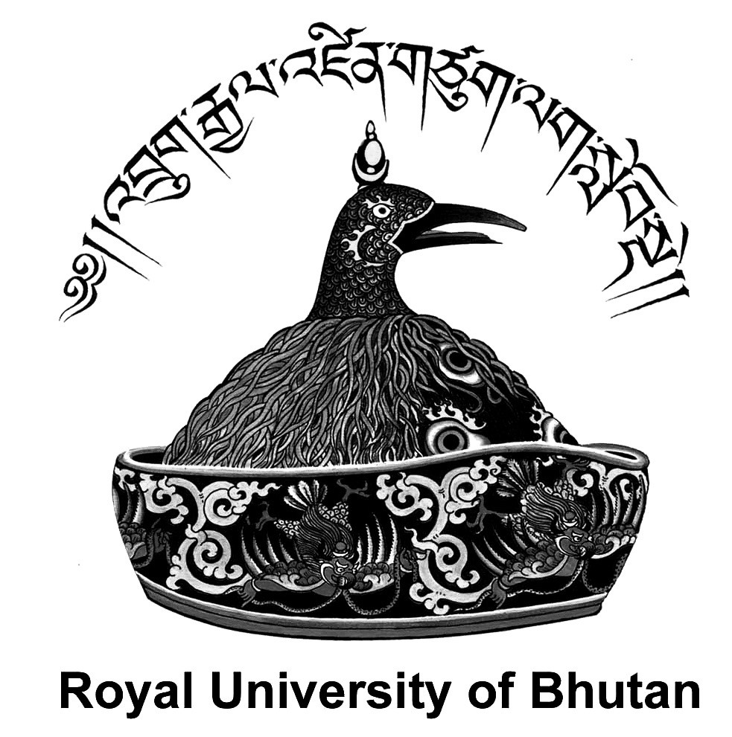
ROYAL UNIVERSITY OF BHUTAN

EMPLOYMENT APPLICATION FORM
Post applied for:
College/Office applied for:
1. PERSONAL DATA
Name:
Citizenship ID number:
Gender:
Date of birth:
Marital status:
Nationality:
Permanent residence:
Village:
Gewog:
Dzongkhag:
Contact number:
Email ID:
I have: (please tick (√) if appropriate)
1.1 Not been convicted of a criminal offence;
1.2 Not been terminated or compulsorily retired from any agency except in case of insolvency;
1.3 Not been adjudged medically unfit for employment by a competent medical doctor;
1.4 Not intentionally provided false information in this application for employment; and
1.5 Not furnished fake/forged testimonials/documents.
2. CURRENT POSITION, if employed
Position Title:
Position Level: Department:
Organisation : Country:
3. EMPLOYMENT RECORD (Most recent employment first)
Employer’s  Institution/ Company  Name | Period of Service |  | Position with the Institution/  Company | Main Roles and  Responsibilities
 | From (dd/ mm/yy) | To (dd/mm/yy)

4. EDUCATION (Please start with institute/college last attended and include information as mentioned in the vacancy announcement)
Institution  (University/College/  School), city and country |  | Aggregate marks obtained |  |  | Duration |  |  |  |  | Educational Qualification
 |  |  |  |  | From (mm/yyyy) |  | To (mm/yyyy)
 |  |  |  |  |  |  |  |  |  | PhD
 |  |  |  |  |  |  |  |  |  | Masters
 |  |  |  |  |  |  |  |  |  | Bachelors
 |  |  |  |  |  |  |  |  |  | Cl.XII (English plus best three subjects)
 |  |  |  |  |  |  |  |  |  | Cl.X (English plus best four subjects)
 |  |  |  |  |  |  |  |  |  | Others (Specify)…..
5. LANGUAGE SKILLS OF RELEVANCE TO THE ASSIGNMENT
(Mention your competency in relation to speaking, reading and writing) (Excellent, Very Good, Good, Average)
Language |  |  | Speaking |  |  | Reading |  |  |  | Writing
Dzongkha
English
6. TRAINING/SEMINAR/WORKSHOP/CONFERENCE (if attended)
Course Attended |  |  |  | Institution/Agency, City and Country |  |  |  | Period  From (mm/yyyy) To (mm/yyyy)
7. RESEARCH PUBLICATIONS (if any)
(Research Papers, Books, Conference Papers, etc. if any, most recent publication first.)
Year: | Title: |  |  |  |  | Type: |  |  | Publisher |  |  | ISSN/  ISBN
8. REFERENCE
Please provide contact details of two references for your application, at least one of which should be a professional reference
Name:
Position Title: Organisation:
Relationship to Applicant:
Telephone: Mobile: E-mail:
Name:
Position Title: Organisation:
Relationship to Applicant:
Telephone: Mobile: E-mail:
9. DOCUMENTS (photocopy) TO BE ATTACHED TO THE APPLICATION:
8.1 Mark sheets & Certificates as announced;
8.2 Valid Bhutanese Citizenship Identity Card;
8.3 Valid Security Clearance Certificate;
8.4 Valid Medical Fitness Certificate; and
8.5 No Objection Certificate from the employer, if employed.
DECLARATION: I hereby declare that the information given herewith is true and complete to the best of my knowledge. In the event of detection of false or misleading information, I understand that the Royal University of Bhutan (RUB) shall withdraw/terminate my service without any recourse; confiscate all my transcription/testimonials; debar from seeking employment in the RUB; and prosecute in the Court of Law for legal actions. I also undertake to abide by all Rules and Regulations.
Affix
Legal
Stamp

Name of the Applicant:
Signature:
Date: For RUB use only
Received by | Date:
 | Time:

